Cardiff Learning Disability Health Team Occupational Therapy Service

Activity | S1: Water Play | Level | Sensory, exploration
keywords | 1:1, Social, Fun, Textures, Relaxing, Tactile, Contact
Links to | P1: Washing up HOH. I1: Washing up FULL

YOU WILL NEED
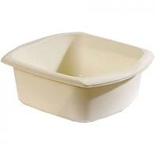 | 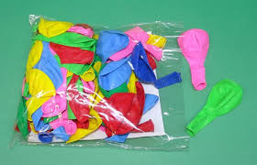 | 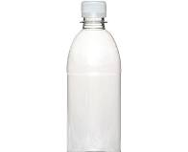 | 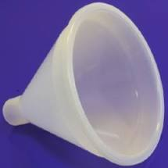 | 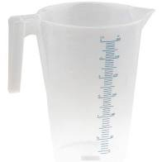 | 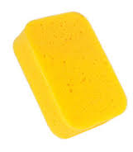
BOWL | BALLOON | BOTTLE | FUNNEL | JUG | SPONGE
 | 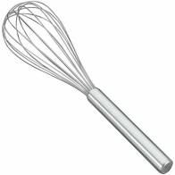 | 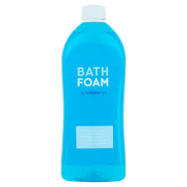 | 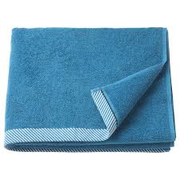 | 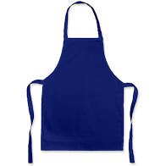
COLLANDER | WHISK | BATH FOAM | TOWEL x 2 | APRON x 2 | BALLS

ACTIVITY FLOW (10 -20 minutes)
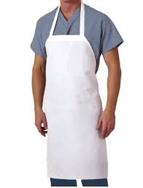 | 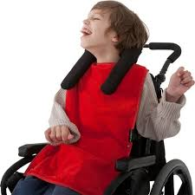 |  |  |  | 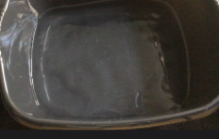 |  | 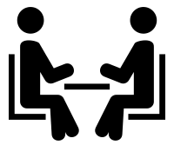
Put on aprons |  |  | Towel on table |  | Warm water |  | Face to Face
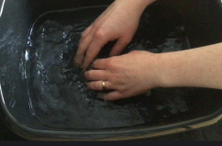 |  |  |  |  |  |  | 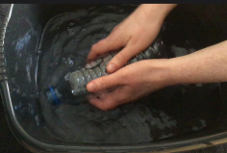
Touch water |  |  | Seive |  | Pour |  | Crunch bottle
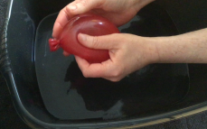 |  |  | 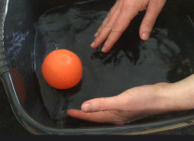 |  |  |  | 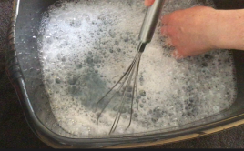
Water Balloon |  |  | Bob balls |  | Add Bubbles |  | Whisk
Feel |  |  | Massage |  | Relax |  | Dry hands

