Helping you with communication during the COVID Pandemic

So we are all spending more time at home, indoors and with each other. There is a lot of change and anxiety for us all.



We have a list of ideas that may be helpful to support you with people who have learning disabilities, communication difficulties, autism. This guidance is from the Learning Disabilities Speech and Language therapy service and focuses on some communication ideas.

**We are of course still in work** and are here to help, contact us at the team base by phone, email or face time and we will work with you to work out the best way to support you at this time. Contact us about any of these ideas or any other communication issue if you need further help!

Within this list of suggestions are some of the current communication challenges you may be facing and many focus around Covid 19. We have included some resources or suggested links to ***free resources*** we hope you will find helpful. What you will need will depend on your own circumstances of course. What you choose to read here and work on here may be just one of these or it may be three of four of them over time. Our suggestions are around:-

* Easy read information on Covid 19
* Routines and visual timetables
* Social stories
* Talking about emotions
* Spending more time together and communication
* Communicating about being unwell and COVID symptoms
* Signing resources and using technology to communicate

**Easy read information**

There are many easy read guides about Corona Virus, in fact the internet is full of them at this time! Some which may be helpful are included below.

Please see:-

* [www.downs-syndrome.org.uk/download-package/coronavirus-what-is-it-how-to-stay-safe-easy-read](http://www.downs-syndrome.org.uk/download-package/coronavirus-what-is-it-how-to-stay-safe-easy-read)
* [www.mencap.org.uk/sites/default/files/2020-03/Info%20about%20covid19%2026th%20March.pdf](http://www.mencap.org.uk/sites/default/files/2020-03/Info%20about%20covid19%2026th%20March.pdf)
* [www.photosymbols.com/blogs/news/coronavirus-poster-set](http://www.photosymbols.com/blogs/news/coronavirus-poster-set)
* <https://drive.google.com/open?id=1f1TVERvsjEbaySZQBTWso5VutJGJWQte>. Lots of really good information about all aspects of living with COVID 19 written by speech and language therapists
* [www.bild.org.uk/wp-content/uploads/2020/03/LD-Senate-Coronavirus-resources-for-use-with-people-with-learning-disabilities-30.3.2020.pdf](http://www.bild.org.uk/wp-content/uploads/2020/03/LD-Senate-Coronavirus-resources-for-use-with-people-with-learning-disabilities-30.3.2020.pdf)

Remember your main source of up to date information about COVID 19 is the **Public Health Wales** website.

Easy read information is helpful to some people with learning disabilities. It is only however part of the way we help people understand and is not meaningful for everyone. We suggest you use them as a guide to talk about it with people or perhaps use some of the information as reminder ‘posters’. You still need to be able to understand sentences in order to understand much of the information produced but what the documents above do is help people understand by using easy words where possible. Pictures help to explain what we mean and to navigate the information.

It takes us all some time to understand what this pandemic means and easy read information is just the same, you will need to go over it with the person and maybe they will only understand some of the information at any time.

**Help people understand what is happening each day**

This may be quite important for the person you are supporting, especially those with autism or those with learning disabilities who have difficulty retaining information. People with autism often don’t cope with change very well it can make them feel anxious. Structure will help us all at this time, whoever we are.

Things that may help

* Structure your day around mealtimes, sleep and normal everyday routines.

This helps highlight what will STILL STAY THE SAME. That will help.

Structure and routine often helps with life being predictable and a sense of control, this helps many people.

* Remember the structure is a goal not a regime and things may need to be a little flexible too.
* To help people understand what is happening show them what you mean, this can be by a written timetable, a photo one or a symbol one
* You might want to keep it simple for some people such as a now and next

Some people may cope with a day or even a week.

* Remember some people may not understand or may not like negatives such as “No swimming”. Telling people places are closed *and* what will happen instead is really important.
* Building in successful activities, favourites and calming activities may help keep the person very focussed and calm.

* Whatever those activities may be such as Lego, watching films, playing games, sorting tasks, doing these are often important for the person. Just make sure they have a balance throughout the day and make sure any new routine you establish now is sustainable or possible to change again.
* At the end of this document we have some templates for you to choose from.
* If you need some symbols have a look at these free resources
* Widgit symbols have a free 30 access at the moment.

[www.widgitonline.com/offer](http://www.widgitonline.com/offer) and register for an account.

Use the code WIDGIT30

* Free symbols on [www.essexice.co.uk](http://www.essexice.co.uk)
* Free symbols on the image bank of [www.easyonthei-leeds.nhs.uk](http://www.easyonthei-leeds.nhs.uk)
* Of course you can ask us and we can help you with this.

**Social stories** may be a helpful way of explaining what is happening, what people will see, what people could do.

They are not simply an explanation of what is happening but they give ideas on what people can do as well.

It’s all about building certainty and predictability for the person.

You need to be able to understand sentences to use them.

The best thing to do is to write them with the person you are supporting.

The structure you could use is:-

* What will happen
* Where we will be
* What we will see
* What we will do
* Who will be there
* Have a look at this website for further explanations and examples

[www.autism.org.uk/about/strategies/social-stories-comic-strips](http://www.autism.org.uk/about/strategies/social-stories-comic-strips)

* [www.bild.org.uk/wp-content/uploads/2020/03/LD-Senate-Coronavirus-resources-for-use-with-people-with-learning-disabilities-30.3.2020.pdf](http://www.bild.org.uk/wp-content/uploads/2020/03/LD-Senate-Coronavirus-resources-for-use-with-people-with-learning-disabilities-30.3.2020.pdf)

**Choice as control**

* All of us have our choices and control over what we do restricted at this time. Lack of control can be stressful. Helping people feel that they have some control over what they are doing can be done by ensuring we offer CHOICE.
* Offering choice to people throughout the day where is a really good way of ensuring people have some control. So some examples include:
* “The swimming pool is shut but you can choose to have a bath or have a foot spa
* “This is what we can do now – you can choose. Do you want to listen to music or watch a film?”
* “Do you want your green socks or white socks?”
* “Do you want the ball or a bean bag”
* Give people plenty of simple everyday choices

For many people who find communicating difficult it is a good idea to

* SHOW THEM WHAT YOU MEAN by holding the items in front of them and naming them

and

* **WAIT** UNTIL THEY reach for, point to, ask for, look at or take the item.

You could also have a choice board of photographs or symbols. Take your own photos or perhaps create a symbol choice board. You can get symbols and picture free from:

* Widgit symbols have a free 30 access at the moment.

[www.widgitonline.com/offer](http://www.widgitonline.com/offer) and register for an account.

Use the code WIDGIT30

* Free symbols on [www.essexice.co.uk](http://www.essexice.co.uk)
* Free symbols on the image bank of [www.easyonthei-leeds.nhs.uk](http://www.easyonthei-leeds.nhs.uk)
* Of course you can ask us and we can help you with this

**Talking about emotions**

* Things are difficult for all of us. It’s good to talk. We all need a lot of reassurance at the moment. It’s good to model talking about what you find difficult AND what you can do about managing that emotion.
* It’s also good to give people praise and feedback for talking about and handling their emotions.
* If your family member has difficulty recognising and talking about their emotions you may find these resources helpful:-
* At the end of this resource we have some emotion symbols you could use. They might be helpful for some people to use to structure the conversation or to point to the symbols
* We also have some signs people may use around emotions
* At the end of this resource there is also a simple and photographic ‘how to stay calm’ leaflet but if you want to create a poster or a chart of what helps the person you work with you can get free symbols and photographs from:
* Widgit symbols have a free 30 access at the moment.

[www.widgitonline.com/offer](http://www.widgitonline.com/offer) and register for an account.

Use the code WIDGIT30

* Free symbols on [www.essexice.co.uk](http://www.essexice.co.uk)
* Free symbols on the image bank of [www.easyonthei-leeds.nhs.uk](http://www.easyonthei-leeds.nhs.uk)
* Talking about emotions when you have any kind of language difficulty is often a challenge if you need any other help do let us know.

**Sharing space and being together perhaps more than usual**

* So you may have more time on your hands to just spend the time interacting. Remember many people need time on their own too!!
* How about creating an ‘ABOUT ME’ story, leaflet or folder? You may have always wanted to do this but never quite had the time. Remember to include important information about how best to communicate with the person, their likes, dislikes, what a good day looks like etc.. If you would like an ‘about me’ structure, page or a communication passport have a look at this webpage for free resources.
* Look at [www.essexice.co.uk](http://www.essexice.co.uk) and look at their picture resources page and their ‘one page profile’ resources.
* For people with little or no verbal communication you can spend real quality time simply interacting without words. We are sure you have many ways of doing this already but if you want to know more ideas on how to do this have a look at these. Some really nice examples of easy approaches include:-
* **The Hanging Out Programme**

[www.sheridanforster.com.au/passions/hanging-out-program-hop/](http://www.sheridanforster.com.au/passions/hanging-out-program-hop/)

www.sheridanforster.files.wordpress.com/2014/08/hop-a5.pdf

* **Intensive interaction**

[www.intensiveinteraction.org](http://www.intensiveinteraction.org)

* **Why not trying bringing the outdoors in and try and create some Sensory Stories?**

These are stories where we bring in actual sensory stimulation to accompany the story. For example if we are talking about a walk in the woods we touch and listen to the crunch of leaves. We use taste, sounds, smells, touch and visual stimulation to enhance the story.

www.youtube.com/watch?v=xJq78KWobmk

Very basic information to start you off.

Here are some easy steps to get you going:-

1. **Choose a story**: Choose a book, story or theme that you both will enjoy - remember you don’t need a book to tell a story!
2. **Summarise it:**Summarise the story into short sentences – about 10 for the whole story is ideal. Keep it short and simple!
3. **Pick 10 keywords:**Think about roughly 10 keywords in the story - these should be the most important for the story to be told and will usually include the who/what/where/doing words.
4. **Find props:**Look around your home for props to bring your sensory story to life - and especially find props to represent your keywords. Props can be anything from using leaves from the garden, a paper fan, ice cubes, a hat.
5. **Make some noise!**You can use sounds, songs, clapping and actions to create a truly sensory story experience. Encourage everyone to join in or make their own sounds and movements.
6. **Use your imagination:**Don’t feel that everything has to be literal. Rain could be the noise of your fingers pattering on the table, a water spray, waggling your fingertips to indicate raindrops falling to the ground or a combination of these things. The more clues you give to help the person understand a word the better.
7. **Repeat, repeat, repeat!**Be ready to tell the same story several times. Repetition is great to help with learning.

**A little note on communication and behaviour**

* Time with others is so important and we may have more of this now. Interaction with others and attention is a fundamental human need. For some people with communication difficulties they could get into a pattern of using behaviour to get their message across or their needs met. At this time you may need to be a little more aware of how behaviours could possibly develop into a way of communicating with you. If you know about this you may be able to avoid this from happening in some circumstances.

So someone may do something such as grab your hand. Initially this may not have any purpose or meaning. It may develop a purpose and meaning however, if we respond to this behaviour over and over and the person learns that this is how they could make you do things.

* So the best thing to do is to reward all appropriate forms of communication or *ask us* how to develop these if you need help.

The other thing would be if at all possible and safe to react, only in a low key way, for example by moving away or ignoring something like a little tug on your clothes. Use your knowledge and judgement of course about safety. Remember as soon as they do something that is a good way of communication respond to that in a positive way, it is appropriate communication we want to reinforce.

* Helping people understand is also so important to help us avoid confusion and anxiety. Some people with speech and language difficulties who do not fully understand what is being said may also resort to challenging behaviour to refuse something or escape the situation. If you need help with helping people to understand you by all means contact us.

For more information on communication and behaviour please see

[www.challenging](http://www.challenging)behvaiour.org.uk

For new and established behaviours that challenge us of course you can continue to get help from the health team for your individual circumstances, we will work out the best ways of helping you at this time.

**Do you know how people communicate when they are unwell or in pain?**

* It can be unclear or difficult for people with learning disabilities to talk about illness or feeling unwell. If you are not too sure about how they do this then you may want to discuss as a team or staff or family what you think happens when they are unwell. As a health team we also have some more structured tools to help us do this, we could discuss these over the phone if you think it would help. For example the DISTDAT tool where we can record how the person behaves when they are calm and also when they seem to be distressed and unwell. This is often helpful for people with little verbal communication.
* For people with more speech and language skills using photographs or symbols to talk about feeling unwell helps them by giving them structure and something to point to.

At the back of this resource we have included some visual communication tools that some of you may find helpful to talk about COVID19 symptoms with the person you are supporting.

Remember to use these yourself with the person to talk about your health so they can see how to do it.

** FOR THE OFFICICAL NHS SYMPTOM CHEKCER PLEASE SEE [www.nhsdirect.wales.nhs.uk/SelfAssessments/symptomcheckers/COVID19](http://www.nhsdirect.wales.nhs.uk/SelfAssessments/symptomcheckers/COVID19)

**Signing**

If you have always wanted to learn how or improve your signing now might be the time to learn together.

If you want to learn how to use some signs have a look at

* Signalong.org.uk. webpage

and twitter signalongcharity – they have free sign videos posted on there every day

* Inclusive Communication Essex – has loads of really useful resources on their website including free ‘how to’ signing videos www.essexice.org.uk

The best way to introduce them is to introduce 2 or 3 signs a day. Make sure you link them to real everyday conversations as that is the best way to use them. Carry on talking as you use the signs as we are using the signs to support talking.

You will only be signing the key words in a sentence e.g.

“Do you want a DRINK?” – you would only need to sign drink.

“Do you want a banana or apple?” – you would only need to sign apple or banana.

Some people with learning disabilities pick up signing very easily. Some people will be able to learn and use a few signs.

Some people may not do the sign very accurately, don’t worry too much about this.

We all may be using face time or zoom a lot so here we have a page of some signs that may help families and friends use. You are welcome to share these of course! Why not teach some family members or friends some signs everyday on face time?

|  |  |  |
| --- | --- | --- |
| M:\My Documents\signs\Signing for CST\good.jpeg | M:\My Documents\signs\activitiy signs\work.jpeg | M:\My Documents\signs\Feelings\wait.jpeg |
| M:\My Documents\signs\Feelings\look see.jpeg | M:\My Documents\signs\Feelings\choice.jpeg | M:\My Documents\signs\Feelings\stop.jpeg |
| M:\My Documents\signs\Feelings\you.jpeg | M:\My Documents\signs\Feelings\me.jpeg | M:\My Documents\signs\Feelings\help.jpeg |

|  |  |  |
| --- | --- | --- |
| M:\My Documents\signs\Art and Craft\same.jpeg | M:\My Documents\signs\Feelings\Yes.jpeg | M:\My Documents\signs\Feelings\no.jpeg |
| M:\My Documents\signs\Food signs\food.jpeg | M:\My Documents\signs\Food signs\drink.jpeg | M:\My Documents\signs\activitiy signs\cook.jpeg |
| M:\My Documents\signs\Places\garden.jpeg | M:\My Documents\signs\activitiy signs\walk.jpeg | M:\My Documents\signs\activitiy signs\music.jpeg |

|  |  |  |
| --- | --- | --- |
| M:\My Documents\signs\activitiy signs\draw.jpeg | M:\My Documents\signs\Art and Craft\paint.jpeg | M:\My Documents\signs\Feelings\sleep.jpeg |

* **A guide to general communication technology**

There are some really useful communication apps for iPads and Android. Here is a list to help you see what they do and how much the cost and which ones a free, you may like to explore these at this time to help you with your everyday communication.

|  |  |  |  |  |
| --- | --- | --- | --- | --- |
| **Name of app** | **Price** | **Platform** | **Description** | **Online tutorials/support/photo examples** |
| Proloquo2 go | £249.99 | Ipad | Symbol/photo based communication app. Can set grid size and add own photos as well as use library of symbols. Has voice output. | <https://www.assistiveware.com/support/proloquo2go/overview> |
| My talk tools mobile | $99.99  (Lite version also available as free trial) | IPad and Android | Symbol/photo based communication app. Can set grid size and can be different gird size on each page. Can add own photos as well as use library of symbols. Can also add videos.  Voice output. | - <https://mytalk.zendesk.com/hc/en-us/categories/201723103-Using-MyTalk> |
| Let me talk | Free | Android and IPad | Symbol/Photo based communication app. Pre-stored symbols, which you can use to make sentences. Can add own categories and use own photos. | <https://youtu.be/OO8ekfLLVGY> |
| Speech Assistant AAC | Free | Android | Text to speech app for those who are non-verbal and have literacy skills. Has some stored phrases. |  |

|  |  |  |  |  |
| --- | --- | --- | --- | --- |
| Pictello | £18.99 | IPad | Create visual stories, online communication passports etc  Voice output | <https://www.assistiveware.com/support/pictello/manuals> |
| Story Creator | Free | IPad | Create visual stories, online communication passports, visual menus etc  Voice output | <https://youtu.be/IhtfdbUEPTk> |
| My picture book | Free | Android | Create visual stories, online communication passports, visual menus etc  Voice output | <https://youtu.be/MIYjVmfIA_E> |
| First Then visual schedule HD | £14.99 | IPad | Create visual schedules, add own photos as well as videos or use symbol library. Several layout options. | <https://youtu.be/yKsMSSPc5ds> |
| What’s next lite | Free for lite version or £1.39 for full version | Android | Visual schedule app |  |
| Timetable | Free | Android | Text base scheduling app. |  |
| TimeBloc | Free | IPad | Text base scheduling app. |  |

|  |  |  |  |  |
| --- | --- | --- | --- | --- |
| Sounding board | Free | Ipad | Create own grids or use pre-made grids. Use own photos or from symbol library. Can adjust grid size and have layers. Good for choice making. | <https://youtu.be/q9o3Nc4Cc2M> |
| Albumbook | Free | IPad and Android | Create photo books online |  |

**Useful links**

Call Scotland IPad app wheel

<https://www.callscotland.org.uk/downloads/posters-and-leaflets/ipad-apps-for-complex-communication-support-needs/>

Call Scotland Android app wheel

<https://www.callscotland.org.uk/downloads/posters-and-leaflets/android-apps-for-complex-communication-support-needs/>

|  |  |  |
| --- | --- | --- |
|  | Morning | Afternoon |
|  |  |  |
|  |  |  |
|  |  |  |
|  |  |  |
|  |  |  |

|  |  |  |  |  |  |
| --- | --- | --- | --- | --- | --- |
| happy 1.WMF  Happy | Ok | Don’t know | sad  Worried | angry 1.WMF  Sad | Angry |

|  |  |
| --- | --- |
| Happy | Sad |
| Worried | Angry |

Basic signs for happy and sad

 

Sign for happy – looks like a clap with no noise Sign for sad you make a sad mouth outline and look sad

|  |  |
| --- | --- |
|  | no |
| Yes | No |

next

now

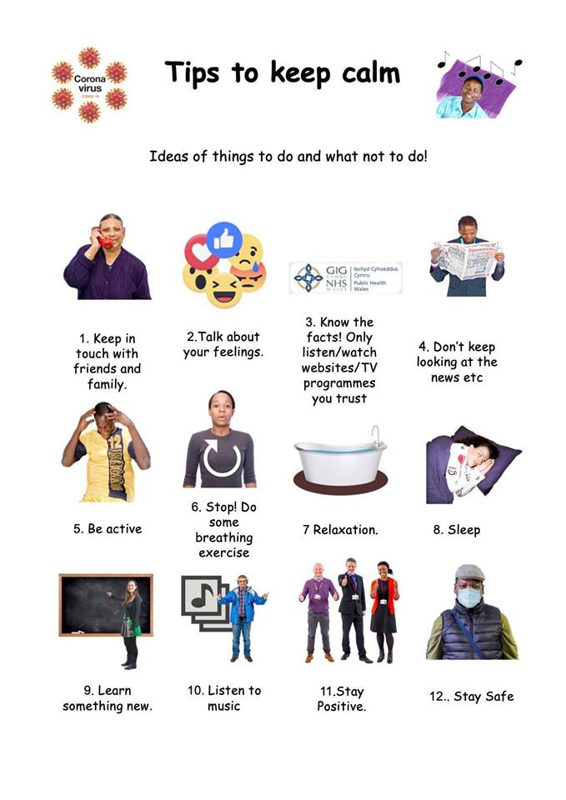

SIGNS for symptoms

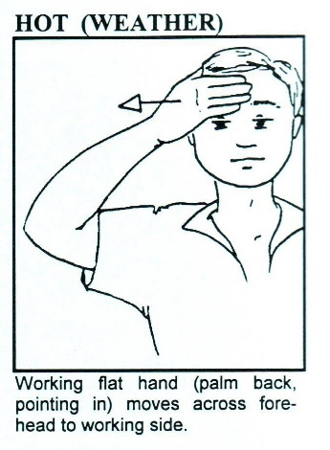 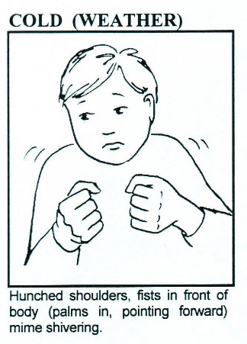

These are the same for feeling hot and cold not just the weather

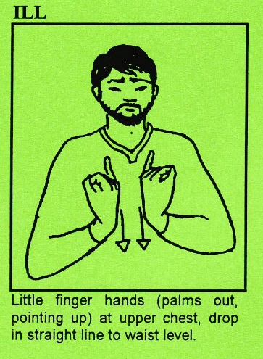 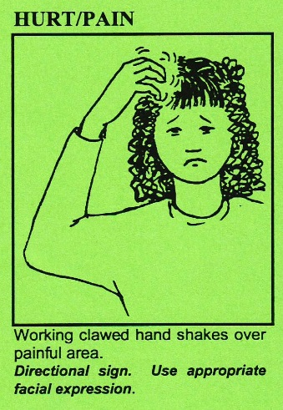

You do this this sign over the part of the

body that hurts

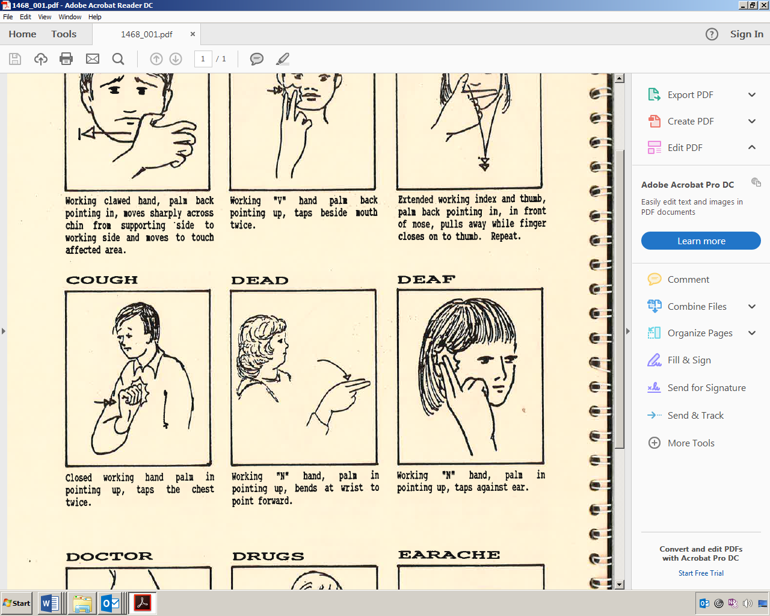 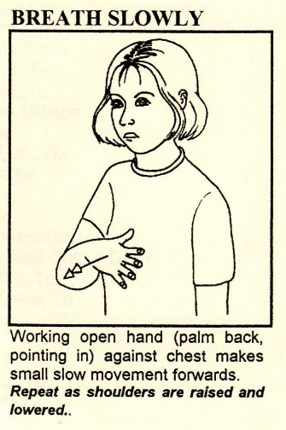

Use this sign to discuss breathing

and thumbs up or down to discuss

breathing ok or not good / bad

|  |  |  |
| --- | --- | --- |
|  | YES | NO |
|  | YES | NO |
|  | YES | NO |
|  | YES | NO |
|  | YES | NO |
|  | YES | NO |
| Other Symptoms |  |  |
| Date |  |  |