Cardiff Learning Disability Health Team Occupational Therapy Service

Activity | R1: Fruit Smoothy | Level | Easy,Sensory, exploration
keywords | 1:1, Social, Fun, Textures, Taste, Achievement, Producer, Healthy
Links to

YOU WILL NEED
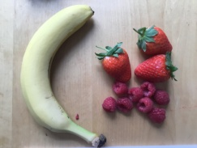 | 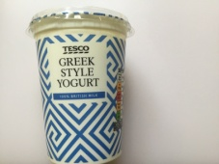 | 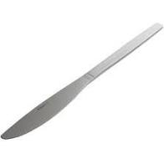 |  | 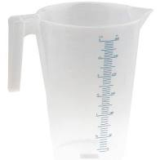 | 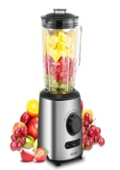
Fruit | Yoghurt | Knife | Chopping board | Jug | Blender

ACTIVITY FLOW (10 -20 minutes)
 |  | 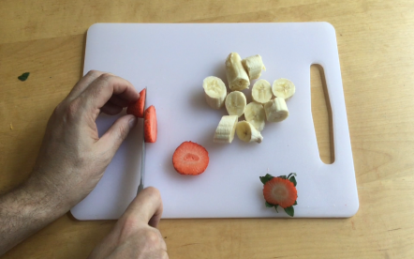 |  | 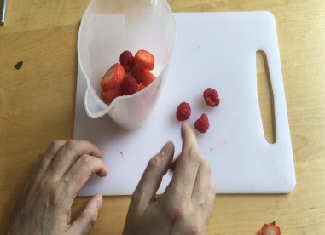
Wash Hands |  | Chop Fruit |  | Place in blender or jug
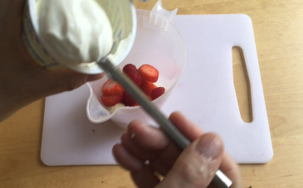 |  | 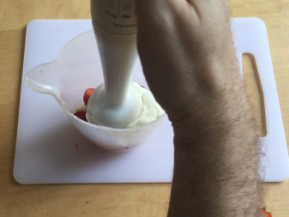 |  | 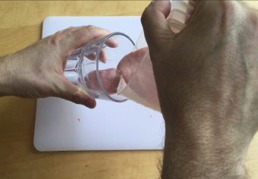
Add yoghurt |  | Blend |  | Pour
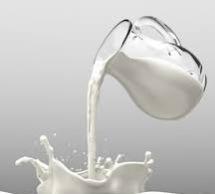 |  | 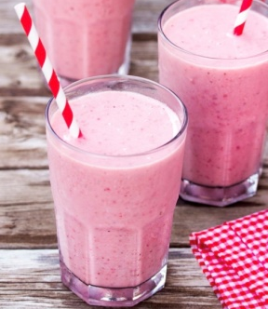
Add milk to thin |  | Serve

