Cardiff Learning Disability Health Team Occupational Therapy Service

Activity | Salt Dough Models | Level
keywords | Activity, creative, touch
Links to

YOU WILL NEED
 |  |  |  | 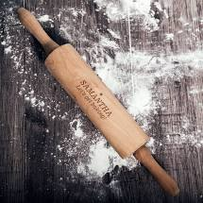 | 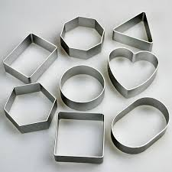
Flour | Salt | Bowl | Water | Rolling pin | Shape cutters

ACTIVITY FLOW (10 -20 minutes)
 |  |  |  | 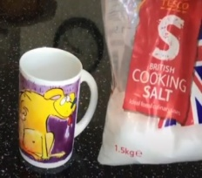
2 CUPS OF FLOUR |  | ADD TO BOWL |  | 1 CUP OF SALT |  | ADD TO BOWL
ADD WATER |  | MIX |  | MAKE A BALL |  | ROLL OUT
 |  |  |  | 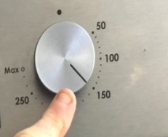
CUT YOUR SHAPE |  | MAKE YOUR PATTERN |  | BAKE AT 150C |  | 4 HOURS

