Cardiff Learning Disability Health Team Occupational Therapy Service

Activity | Pizza Toast | Level
keywords | Fun, Independence, Engagement, Productivity, Nutrition, Taste, Cooking
Links to

YOU WILL NEED
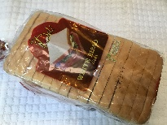  Bread | 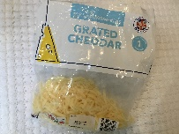  Cheese | 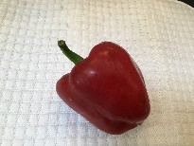  Red Pepper | 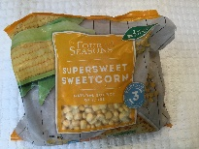  Sweetcorn | 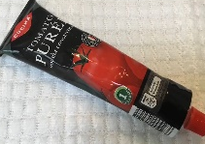  Tomato Paste
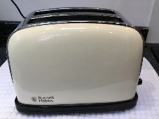  Toaster | 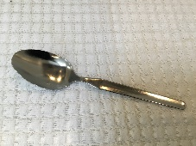  Tablespoon | 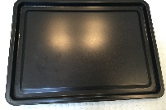  Tray | 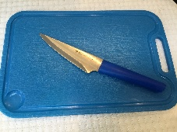  Knife and chopping board

ACTIVITY FLOW (10 -20 minutes)
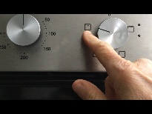 |  |  |  |  |  | 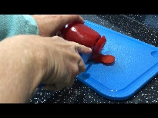
Turn on the grill |  | 2 slices of bread |  | Toast |  | Chop the pepper
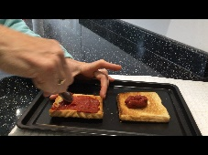 |  | 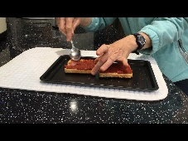 |  | 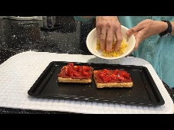 |  | 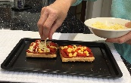
Spread the tomato paste |  | Add peppers |  | Add the sweetcorn |  | Sprinkle cheese on top
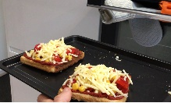 |  | 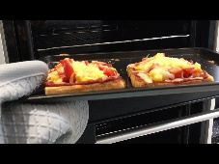 |  | 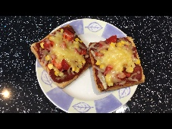
Grill until the cheese melts |  | Remove from the grill HOT |  | Eat

