Cardiff Learning Disability Health Team Occupational Therapy Service

Activity | Mindful senses | Level | Sensory, relaxation
Keywords | Sensory, relaxation, mindfulness, anxiety, overwhelmed
Links to

YOU WILL NEED
A room with an open window

ACTIVITY FLOW (5 minutes)
Sit in a comfortable position. |  | Breathe in through your nose. |  | Breathe out through your mouth. |  | 3  Do this 3 times.
10  Count 10 more breaths |  | 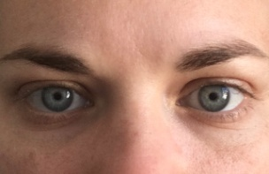  Keep your eyes open. |  | What 5 things can you see? |  | 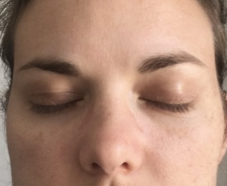  Close your eyes.
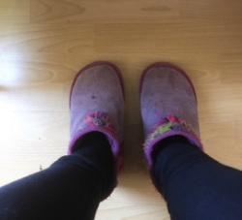  What 4 things can you feel with your body? |  | 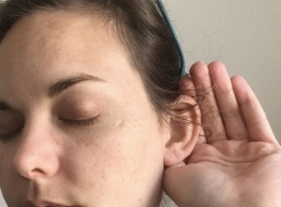  What 3 things can you hear? |  | What 2 things can you smell? |  | What 1 thing can you taste?

