HOSPITAL INFORMATION PASSPORT

HELLO
MY NAME IS

RED | AMBER | GREEN
Things you must know about me | Things you should  Know about me. | Things I would like to happen.

.

IMPORTANT
Things you must know about me

My name is: |  |  |  | Known as:
GP name: |  |  |  | Practice name:
GP address:
GP Telephone number: |  |  |  | My NHS No :
My date of birth:
My address is:
My telephone number is:
Where I live (X) | Family |  | Independently |  |  | Supported living
My Religion is: |  |  |  | Religious requirements:

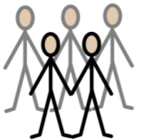 | People in my life

Next of kin: |  | Relationship: |  |  | Tel:
Main Carer: |  | Relationship: |  |  | Tel:
Case/Care Manager: |  |  |  |  | Tel:
Most important person to me

Professionals Involved: |  |  | Relationship |  | Telephone:

All about my health

 | Current Medical Conditions:
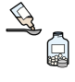 | Current Medication: Please check these are up to date
 | Brief Medical History:
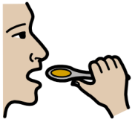 | Eating and Drinking:
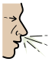 | Allergies:
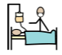 | Medical interventions:
 | Communication: my understanding, how I express myself and how you can help me
 | Behaviours which may challenge or cause risk:
Please see additional documents:
e.g
- Epilepsy, profile, Disdat, mealtime placemat

Completed By:
Relationship:
Signature: |  | Date:

Things You Should Know About Me

Going to the toilet
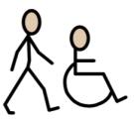
Getting around at home and outside
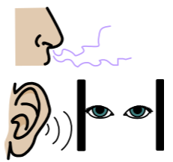
Sensory needs
Personal care

Things You Should Know About Me

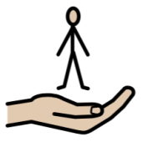
Level of support
Things that keep me calm
Keeping safe
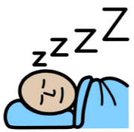
Sleeping
Pain

Completed By:
Relationship:
Signature: |  | Date:

Things That Will Make My Stay More Enjoyable

Things I Like

Things I Don’t Like
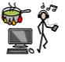
Things I like to do

Completed By:
Relationship:
Signature: |  | Date:

Adapted from the Red, Amber, Green Hospital Assessment: Gloucestershire Partnership NHS Trust (Elliot & Dean 2004)

