Today’s rules

Today is:

Rule 1 is:

Rule 2 is:

Rule 3 is:

Rule 4 is:

Rule 5 is:

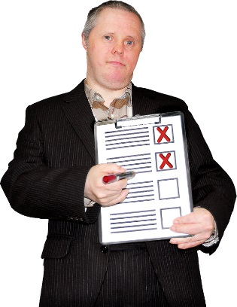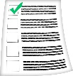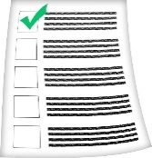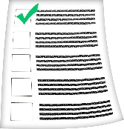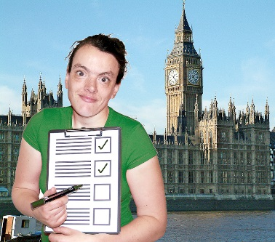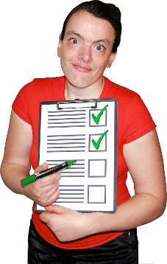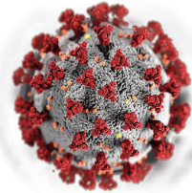

Sometimes the rules will be the same as yesterday

You should write the rules down on the rules sheet

These rules will change

These rules come from the government

We all have to follow rules to stop people getting Covid 19

There is a virus called Covid 19 which makes people ill

You or someone you trust should check on the news to find the rules for the day